
Customer Relationship Management
✅ Introduction
The Customer Relationship Management (CRM) system is a web-based application designed to help businesses manage interactions with current and potential customers. It centralizes customer information, automates marketing and sales processes, and enhances customer service. The CRM system provides a secure, efficient, and user-friendly platform for sales, marketing, and customer support teams. Key features include lead management, sales pipeline tracking, communication logs, and performance analytics.

✅ Purpose of CRM
The purpose of CRM is to:
• Enhance customer relationship management: Centralizing and tracking customer interactions to improve communication, satisfaction, and retention.
• Streamline sales and marketing processes: Automating tasks such as lead capture, follow-ups, and email campaigns to improve conversion rates and team efficiency.
• Maintain accurate and up-to-date customer data: Storing contact details, communication history, and deal status in a centralized system to ensure quick and informed decision-making.
• Provide secure access for different roles: Using role-based authentication to protect customer data and allow only authorized users to view or modify information.
• Improve data-driven decision-making: Offering real-time insights and reports on sales performance, customer behavior, and market trends, empowering teams to take proactive actions.
• Reduce manual work and increase productivity: Automating repetitive tasks such as reminders, emails, and status updates to allow staff to focus on high-value activities.
✅ Login Page Overview for CRM System
The Login Page is a crucial entry point into the CRM application. It ensures secure user authentication and acts as the gateway for accessing CRM functionalities such as lead management, contact tracking, sales pipeline monitoring, and customer support. This document outlines the essential elements, visual design considerations, and functionality of the CRM login page, prioritizing both ease of use and high-level data security.

✅ Key Elements of the Login Page
• Branding and Logo
○ The CRM system logo is displayed prominently at the top to reinforce brand identity and ensure familiarity for the user.
• Login Form
○ Username/Email Input Field: A text field where users can enter their registered email address or username to begin authentication.
○ Password Input Field: A secure field for entering the password, which hides the typed characters to protect user privacy.
○ Remember Me Checkbox (optional): Allows users to remain logged in on the device for convenience, depending on security policy.
○ Login Button: A distinct and accessible button used to submit credentials and authenticate the user.

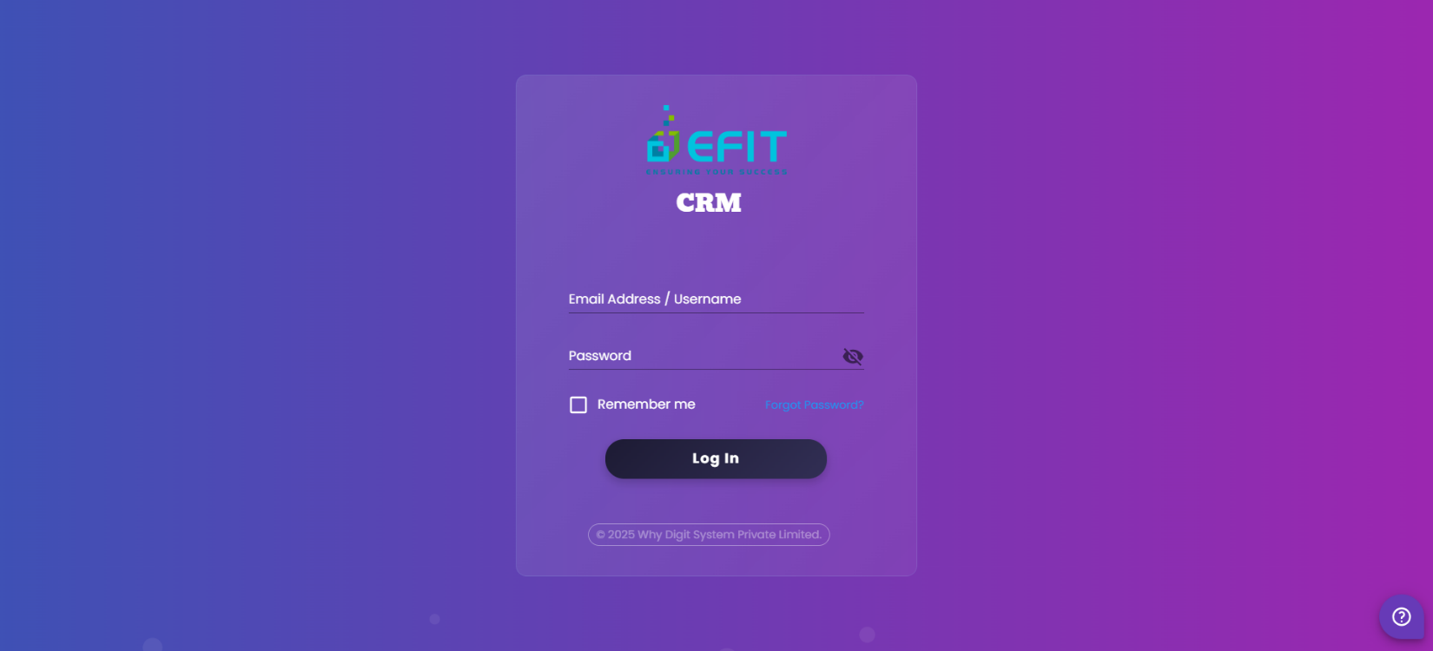
✅ Company Setup
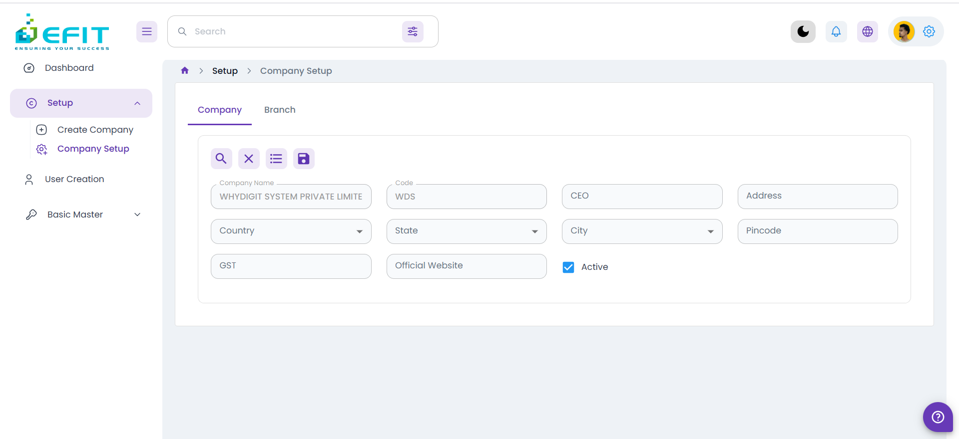
The Company Setup screen in the CRM system enables administrators to configure core organizational details and manage multiple branches or business units. This functionality is essential for organizations operating across various locations, allowing centralized control over sales regions, customer assignments, and reporting structures. It ensures that the CRM data is organized effectively for streamlined customer relationship management across all company branches.

✅ Branch
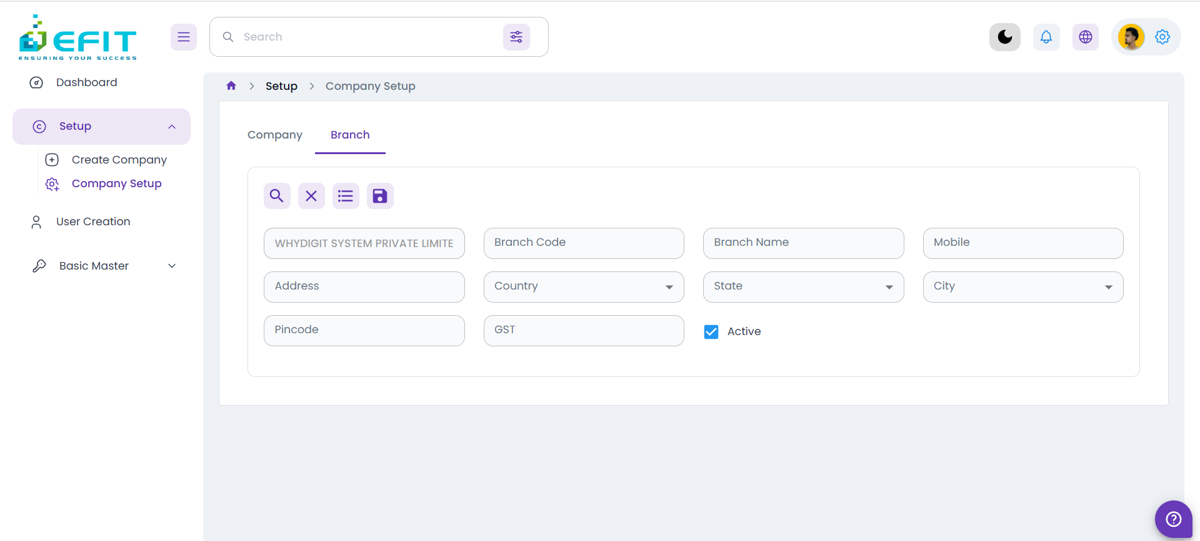
- Allows the addition of multiple branches under a company to support multi-location operations.
- Assigns unique branch codes to distinguish between various regional offices or sales territories.
- Stores branch-specific details such as location, contact person, phone number, and assigned sales teams.
- Enables the assignment of branch-level sales or support managers to oversee local CRM operations and ensure region-specific customer engagement and performance tracking.
✅ User Creation
The User Creation screen in the CRM system allows administrators to create and manage user accounts, ensuring secure and role-based access to CRM functionalities. This screen is essential for onboarding sales representatives, marketing users, support staff, and managers, while assigning appropriate roles and permissions to control access to customer data, sales pipelines, and reporting features.

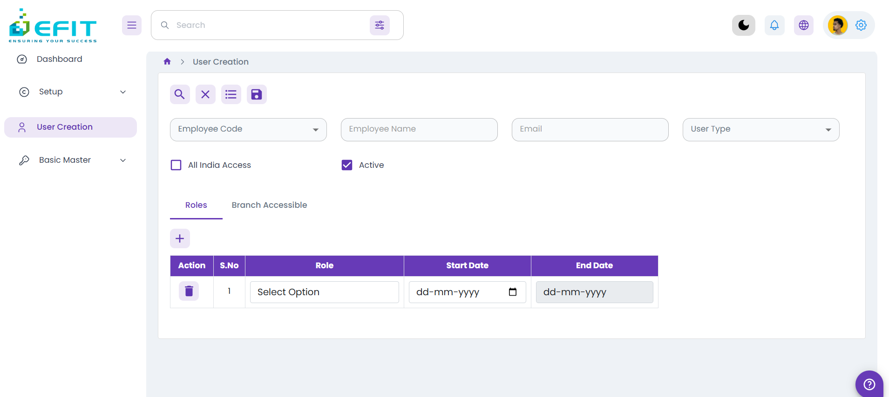
✅ Roles and Responsibilities
The Roles and Responsibilities screen in the CRM system enables administrators to define user roles and assign specific permissions based on the organizational structure. This feature ensures that users have controlled access to CRM modules such as leads, contacts, deals, reports, and dashboards, according to their job functions. It helps enforce data security, prevent unauthorized access, and streamline task management across departments like Sales, Marketing, and Customer Support.
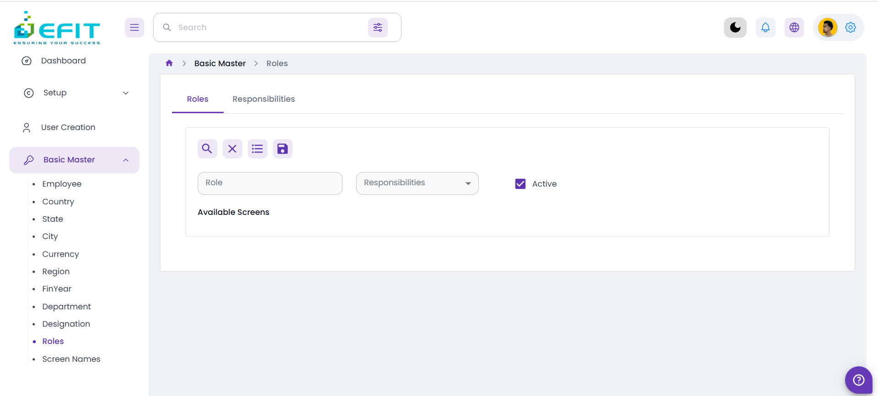

✅ Screen Names
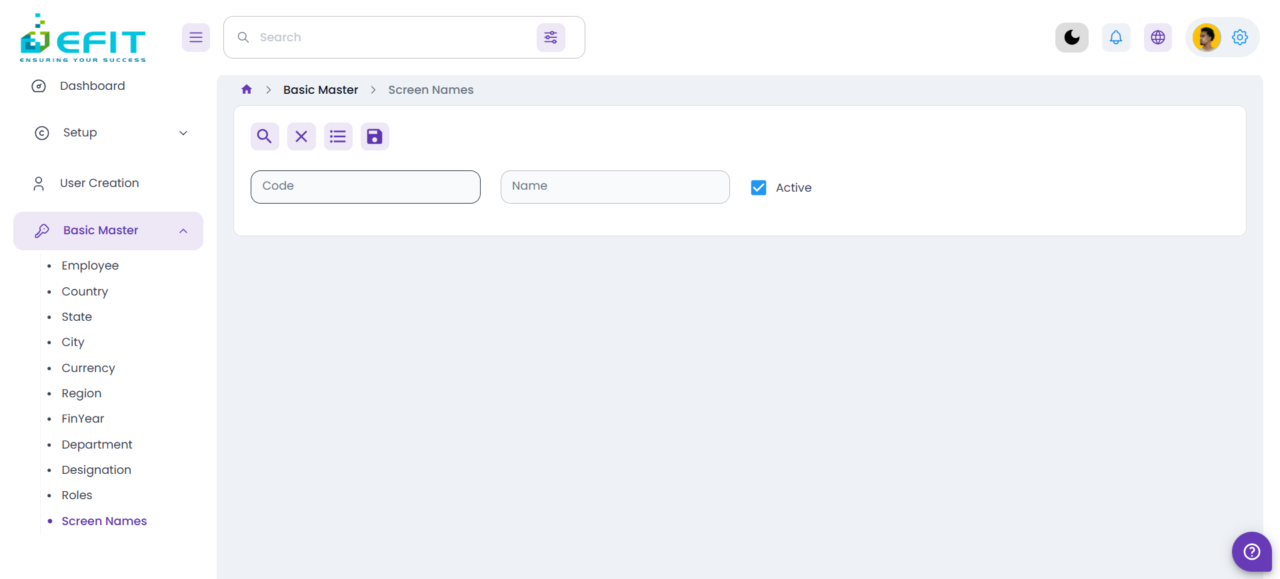
The Screen Names section in the CRM system is responsible for organizing and managing various modules and functionalities such as Leads, Contacts, Deals, Accounts, and Reports. It facilitates intuitive navigation, improves user experience, and supports efficient access control by aligning screen visibility with user roles. This structure ensures that users can easily find and access the specific CRM features relevant to their responsibilities, promoting streamlined customer management and operational efficiency.
✅ Basic Master
The Basic Master section in the CRM system acts as the foundational configuration area where administrators define and manage essential organizational data. This centralized setup ensures consistency and accuracy across all CRM modules. Key configurable elements include:
- Country – Add and manage countries where the organization has customers or operates business units.
- State – Define states or provinces under each country for regional segmentation.
- City – Register cities to support location-specific customer management or sales assignments.
- Currency – Set default currencies for deal values, revenue tracking, and regional reports.
- Region – Organize operational areas or sales zones for territory-based planning.
- Department – Create and manage internal departments (e.g., Sales, Marketing, Support) for structured workflow.
- Designation – Define job titles and user positions to control CRM access and responsibilities.
- Employee – Register CRM users such as sales reps, account managers, and support agents.
- FinYear – Set financial years to standardize reporting and target tracking periods.
This structured setup enhances operational efficiency, promotes standardization, and supports accurate analytics within the CRM system.

✅ Support Center
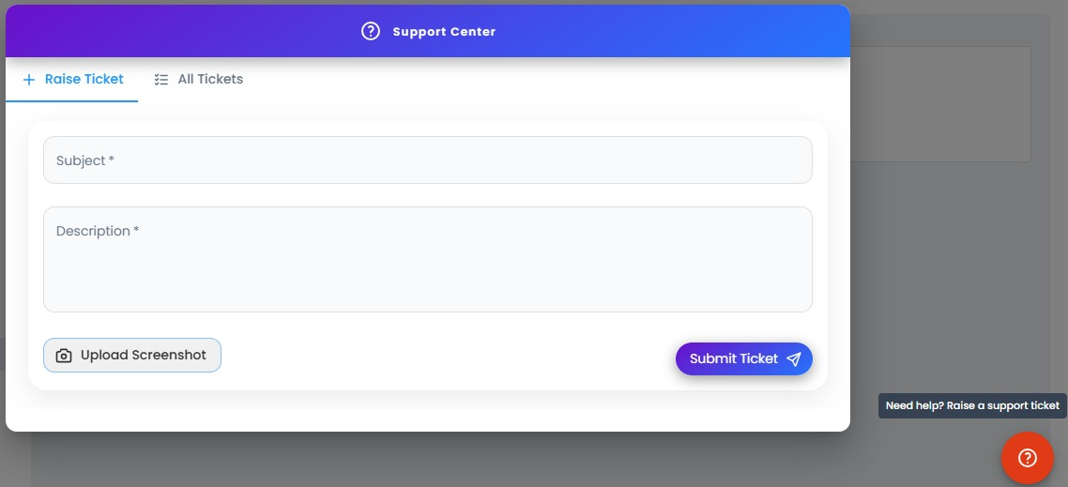
The Support Center module in our HRMS allows users to easily raise issues, request technical help, or ask queries directly through the system. It streamlines communication between employees and the support team, ensuring timely resolution and tracking of all tickets.
Key Features
Raise Ticket Interface:
Users can submit new tickets by providing the issue Subject and Description, and optionally attach a screenshot for better clarity.
Upload Screenshot:
A dedicated button allows users to attach relevant screenshots to help the support team understand the issue better.
Submit Ticket Button:
Once the required information is filled in, the ticket can be submitted instantly for review by the support staff.
All Tickets View:
Users can click on the All Tickets tab to view the history of tickets raised, their status (Open, In Progress, Resolved), and responses from the support team.

